

|  |  |  |  |
| --- | --- | --- | --- |
| **Academic Year** | **Module** | **Assessment Number** | **Assessment Type** |
| A19 | Introduction to Programming I(DipIT04) | A2 | Group Report |

Hotel Management System

Student Id : Np03a180161

Student Name : Sujan Pyakurel

Section : ADC9

Module Leader : Raj Prasad Shrestha

Lecturer : Rizzu Rohit Bhandari

Group Name : Only Sujan

Submitted on : 15-02-2020

|  |  |  |  |  |
| --- | --- | --- | --- | --- |
| **S.N** | **Title** | **Full Marks** | **Obtained Marks** | **Comments** |
| 1 | Format of Report [Report title, Module title,Student names,Group Name] | 2 |  |  |
| 2 | Abstract | 2 |  |  |
| 3 | Acknowledgment | 2 |  |  |
| 4 | Table of contents and list of figures | 2 |  |  |
| 5 | Project description and applications | 3 |  |  |
| 6 | Project algorithm, pseudocode and flowchart | 10 |  |  |
| 7 | C Source Code | 3 |  |  |
| 8 | Testing with screenshots | 3 |  |  |
| 9 | Conclusion and References | 3 |  |  |
| 10 | Continuous Assessments ( 5 % ) |  | | Total Marks Obtained |
|  | Sujan Pyakurel and Np03a180161 | 15 |  |  |
|  | Full Marks | 35 |  |  |

ABSTRACT

Hotels currently use a manual system for the management and maintenance of the information. The current system requires huge number of paper forms, with data stores spread throughout the Hotel management. A significant part of the operation of any hotel involves the management and timely retrival of great volumes of information.

Hotel Management System is a application based program which is developed with basics knowledge on C programming language. It aims at maintaining database in a hotel. This app can run various functions like creating a customer’s database with multiple functionalities like adding and deleting records, update, search and view.

ACKNOWLEDGEMENT

The making of the report needed co-operation and guidance of a number of people. I therefore consider it my prime duty to thank all those who had helped me for making it successful. It is my immense pleasure to express my gratitude to Rizzu Rohit sir (Lecturer and tutor of Introduction to Programming I) as a guide who provided me constructive and positive feedback during the preparation of this report. No words can explain my gratitude for your ever helping hand through this process. Last but not least, I am thankful to my friends whose encouragement and suggestion helped me to complete my report.

However, I can’t forget the support that both my school administration and my family have granted me through this process.

Sincerely,

Sujan Pyakurel

Contents

1. INTRODUCTION 7

2.PROJECT DESIGN 8

3.C SOURCE CODE 9

4.IMPLEMENTATION 19

5.CONCLUSION 24

REFERENCES 25

LIST OF FIGURES

Figure 1 Flow Chart of Hotel Management System 8

Figure 2 Welcome Page 19

Figure 3 Login 19

Figure 4 Login Unsuccessful 19

Figure 5 Main Menu 20

Figure 6 Incorrect Input in Main Menu 20

Figure 7 Booking a Room 20

Figure 8 Room Booking 21

Figure 9 Room Booked Successfully 21

Figure 10 View Customer Records 22

Figure 11 Deleting Customer Records 22

Figure 12 Customer Records after Deletion Action Performed 22

Figure 13 Records not Found for Unregistered Customer Record Deletion 22

Figure 14 Search Functionality 22

Figure 15 Search Operation for Unregistered Customer Records 23

Figure 16 Edit Record 23

Figure 17 Customer Record after Editing 23

Figure 18 Exit and Thanksgiving Page 23

# 1. INTRODUCTION

“HOTEL MANAGEMENT SYSTEM”, is a project for keeping and maintaining customers record in a hotel. The main objective of the project is to computerize the system of the hotel. ”Hotel Management System” not only keeps and maintains records but also reduce the extensive paper work in the present system. It also helps to maintain clean records. Besides it saves time, money and doesn’t require additional manpower. (SCRIBD, 2010)

I have used some basic programming concepts such as file handling. Different operations that can be done on a file are:

1. Creation of a new file(fopen with attributes as “a+” or “w+”).
2. Opening an existing file(fopen).
3. Closing a file(fclose).
4. Changing the file position indicator(fseek).
5. reading data from the given stream into the array pointed to, by size, stream(fread).

Initialing the value at the beginning of program and keep checking it whenever required(flag).I have also used control statements such as if-else, do-while, while, etc.

# 2.PROJECT DESIGN

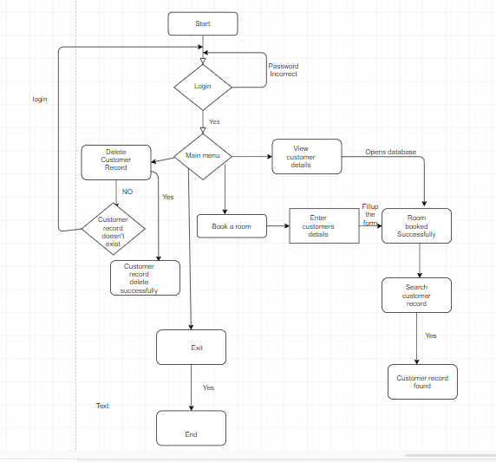

Figure Flow Chart of Hotel Management System

# 3.C SOURCE CODE

#include<stdio.h>

#include<conio.h>

#include<windows.h>

#include<stdlib.h>

#include<time.h>

void add(); //FUNCTIONS

void list();

void edit(); //GLOBALLY DECLARED FUNCTIONS AND VARIABLE

void delete1();

void search();

void login()

{

int a=0,i=0;

char uname[10],c=' ';

char pword[10],code[10];

char user[10]="user";

char passwd[10]="passwd";

do

{

system("cls");

printf("\n ********************* LOGIN FORM ********************* ");

printf(" \n ENTER USERNAME:-");

scanf("%s", &uname);

printf(" \n ENTER PASSWORD:-");

while(i<8)

{

pword[i]=getch();

c=pword[i];

if(c==13) break;

else printf("*");

i++;

}

pword[i]='\0';

//char code=pword;

i=0;

//scanf("%s",&pword);

if(strcmp(uname,user)==0 && strcmp(pword,passwd)==0)

{

printf(" \n\n\n WELCOME !!!! LOGIN SUCCESSFUL");

break;

}

else

{

printf("\n SORRY !!!! LOGIN UNSUCESSFUL");

a++;

getch();

}

}

while(a<=4);

if (a>4)

{

printf("\nSorry!! The username or password you have entered didn't matched for five times!!!");

getch();

}

system("cls");

}

struct CustomerDetails //DECLARING STRUCTURE

{

char roomnumber[5];

char name[20];

char address[25];

char phonenumber[15];

char nationality[15];

char email[50];

char period[10];

char arrivaldate[10];

}s;

int main(){ // MAIN FUNCTION

int i=0;

time_t t;

time(&t);

char customername;

char choice;

system("cls"); // TO CLEAR SCREEN

printf(" -------------------------------------------------------------------------\n");

printf("\t\t*********************NAMASTE*********************\n");

printf(" -------------------------------------------------------------------------\n");

printf("\t\t*************************************************\n");

printf("\t\t* *\n");

printf("\t\t* ............................... *\n");

printf("\t\t* : WELCOME TO HOTEL Andromeda : *\n");

printf("\t\t* ............................... *\n");

printf("\t\t* *\n");

printf("\t\t* CONTACT US:HotelAndromeda@gmail.com *\n");

printf("\t\t*************************************************\n\n\n");

for(i=0;i<80;i++)

printf("-");

printf("\nCurrent date and time : %s",ctime(&t));

for(i=0;i<80;i++)

printf("-");

printf(" \n Press any key to continue:");

getch();

system("cls");

login();

system("cls");

while (1) // INFINITE LOOP

{

system("cls");

for(i=0;i<80;i++)

printf("-");

printf("\n");

printf(" ****************************** |MAIN MENU| ***************************** \n");

for(i=0;i<80;i++)

printf("-");

printf("\n");

printf("\t\t *Please enter your choice for menu*:");

printf("\n\n");

printf(" \n Enter 1 -> Book a room");

printf("\n------------------------");

printf(" \n Enter 2 -> View Customer Record");

printf("\n----------------------------------");

printf(" \n Enter 3 -> Delete Customer Record");

printf("\n-----------------------------------");

printf(" \n Enter 4 -> Search Customer Record");

printf("\n-----------------------------------");

printf(" \n Enter 5 -> Edit Record");

printf("\n-----------------------");

printf(" \n Enter 6 -> Exit");

printf("\n-----------------");

printf("\n");

for(i=0;i<80;i++)

printf("-");

printf("\nCurrent date and time : %s",ctime(&t));

for(i=0;i<80;i++)

printf("-");

choice=getche();

choice=toupper(choice);

switch(choice) // SWITCH STATEMENT

{

case '1':

add();break;

case '2':

list();break;

case '3':

delete1();break;

case '4':

search();break;

case '5':

edit();break;

case '6':

system("cls");

printf("\n\n\t *****THANK YOU*****");

printf("\n\t**VISIT US AGAIN!!!** ");

// Sleep(2000);

exit(0);

break;

default:

system("cls");

printf("Incorrect Input");

printf("\n Press any key to continue");

getch();

}

}

}

void add()

{

FILE *f;

char test;

f=fopen("add.txt","a+");

if(f==0)

{ f=fopen("add.txt","w+");

system("cls");

printf("Please hold on while we set our database in your computer!!");

printf("\n Process completed press any key to continue!! ");

getch();

}

while(1)

{

system("cls");

printf("\n Enter Customer Details:");

printf("\n**************************");

printf("\n Enter Room number:\n");

scanf("\n%s",s.roomnumber);

fflush(stdin);

printf("Enter Name:\n");

scanf("%s",s.name);

printf("Enter Address:\n");

scanf("%s",s.address);

printf("Enter Phone Number:\n");

scanf("%s",s.phonenumber);

printf("Enter Nationality:\n");

scanf("%s",s.nationality);

printf("Enter Email:\n");

scanf(" %s",s.email);

printf("Enter Period(\'x\'days):\n");

scanf("%s",&s.period);

printf("Enter Arrival date(dd\\mm\\yyyy):\n");

scanf("%s",&s.arrivaldate);

fwrite(&s,sizeof(s),1,f);

fflush(stdin);

printf("\n\n1 Room is successfully booked!!");

printf("\n Press esc key to exit, any other key to add another customer detail:");

test=getche();

if(test==27)

break;

}

fclose(f);

}

void list()

{

FILE *f;

int i;

if((f=fopen("add.txt","r"))==NULL)

exit(0);

system("cls");

printf("ROOM ");

printf("NAME\t ");

printf("\tADDRESS ");

printf("\tPHONENUMBER ");

printf("\tNATIONALITY ");

printf("\tEMAIL ");

printf("\t\t PERIOD ");

printf("\t ARRIVALDATE \n");

for(i=0;i<118;i++)

printf("-");

while(fread(&s,sizeof(s),1,f)==1)

{

/*printf("ROOMNUMBER :\t%s\n",s.roomnumber);

printf("NAME:\t%s\n",,s.name);

printf("ADDRESS:\t%s\n",s.address);

printf("PHONENUMBER:\t%s\n",s.phonenumber);

printf("NATIONALITY \n");*/

printf("\n%s \t%s \t\t%s \t\t%s \t%s \t%s \t %s \t %s",s.roomnumber, s.name , s.address , s.phonenumber ,s.nationality ,s.email,s.period, s.arrivaldate);

}

printf("\n");

for(i=0;i<118;i++)

printf("-");

fclose(f);

getch();

}

void delete1()

{

FILE *f,*t;

int i=1;

char roomnumber[20];

if((t=fopen("temp.txt","w"))==NULL)

exit(0);

if((f=fopen("add.txt","r"))==NULL)

exit(0);

system("cls");

printf("Enter the Room Number of the hotel to be deleted from the database: \n");

fflush(stdin);

scanf("%s",roomnumber);

while(fread(&s,sizeof(s),1,f)==1)

{

if(strcmp(s.roomnumber,roomnumber)==0)

{ i=0;

continue;

}

else

fwrite(&s,sizeof(s),1,t);

}

if(i==1)

{

printf("\n\n Records of Customer in this Room number is not found!!");

//remove("E:/file.txt");

//rename("E:/temp.txt","E:/file.txt");

getch();

fclose(f);

fclose(t);

main();

}

fclose(f);

fclose(t);

remove("add.txt");

rename("temp.txt","add.txt");

printf("\n\nThe Customer is successfully removed....");

fclose(f);

fclose(t);

getch();

}

void search()

{

system("cls");

FILE *f;

char roomnumber[20];

int flag=1;

f=fopen("add.txt","r+");

if(f==0)

exit(0);

fflush(stdin);

printf("Enter Room number of the customer to search their details: \n");

scanf("%s", roomnumber);

while(fread(&s,sizeof(s),1,f)==1)

{

if(strcmp(s.roomnumber,roomnumber)==0){

flag=0;

printf("\n\tRecord Found\n ");

printf("\nRoom Number:\t%s",s.roomnumber);

printf("\nName:\t%s",s.name);

printf("\nAddress:\t%s",s.address);

printf("\nPhone number:\t%s",s.phonenumber);

printf("\nNationality:\t%s",s.nationality);

printf("\nEmail:\t%s",s.email);

printf("\nPeriod:\t%s",s.period);

printf("\nArrival date:\t%s",s.arrivaldate);

flag=0;

break;

}

}

if(flag==1){

printf("\n\tRequested Customer could not be found!");

}

getch();

fclose(f);

}

void edit()

{

FILE *f;

int k=1;

char roomnumber[5];

long int size=sizeof(s);

if((f=fopen("add.txt","r+"))==NULL)

exit(0);

system("cls");

printf("Enter Room number of the customer to be updated:\n\n");

scanf("%[^\n]",roomnumber);

fflush(stdin);

while(fread(&s,sizeof(s),1,f)==1)

{

if(strcmp(s.roomnumber,roomnumber)==0)

{

k=0;

printf("\nEnter Room Number :");

gets(s.roomnumber);

printf("\nEnter Name :");

fflush(stdin);

scanf("%s",&s.name);

printf("\nEnter Address :");

scanf("%s",&s.address);

printf("\nEnter Phone number :");

scanf("%f",&s.phonenumber);

printf("\nEnter Nationality :");

scanf("%s",&s.nationality);

printf("\nEnter Email :");

scanf("%s",&s.email);

printf("\nEnter Period :");

scanf("%s",&s.period);

printf("\nEnter Arrival date :");

scanf("%s",&s.arrivaldate);

fseek(f,size,SEEK_CUR); //to go to desired position infile

fwrite(&s,sizeof(s),1,f);

break;

}

}

if(k==1){

printf("\n\nTHE RECORD DOESN'T EXIST!!!!");

fclose(f);

getch();

}else{

fclose(f);

printf("\n\n\t\tYOUR RECORD IS SUCCESSFULLY UPDATED!!!");

getch();

}

}

# 4.IMPLEMENTATION

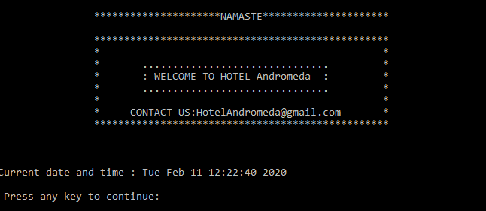

Figure 2 Welcome Page

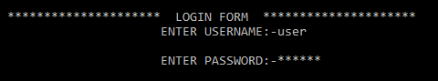

Figure 3 Login

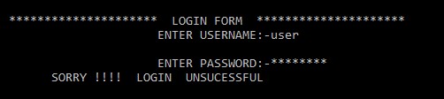

Figure 4 Login Unsuccessful

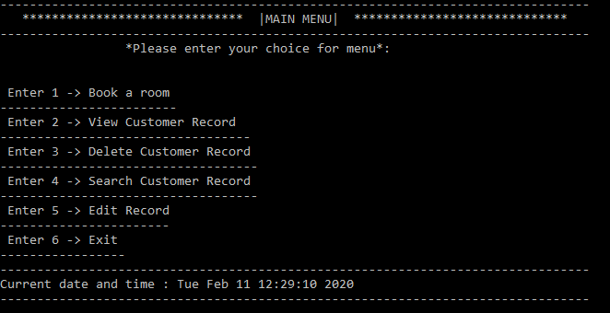

Figure 5 Main Menu

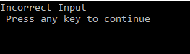

Figure 6 Incorrect Input in Main Menu

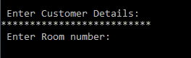

Figure 7 Booking a Room

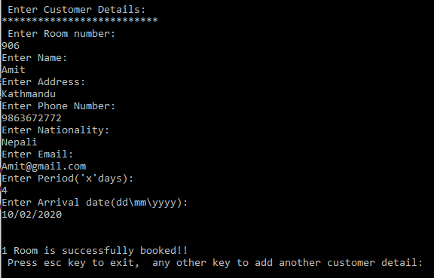

Figure 8 Room Booking

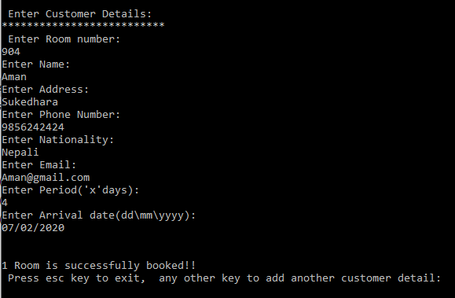

Figure 9 Room Booked Successfully

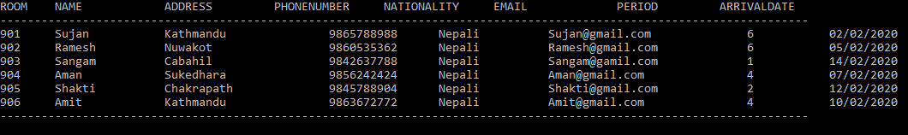

Figure 10 View Customer Records

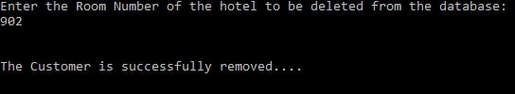

Figure 11 Deleting Customer Records

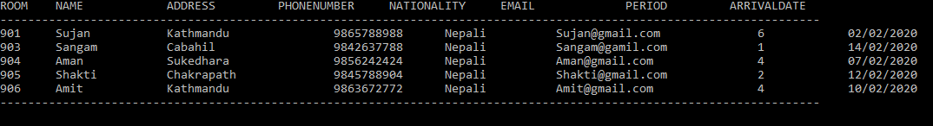

Figure 12 Customer Records after Deletion Action Performed

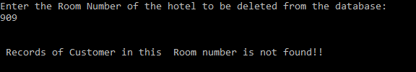

Figure 13 Records not Found for Unregistered Customer Record Deletion

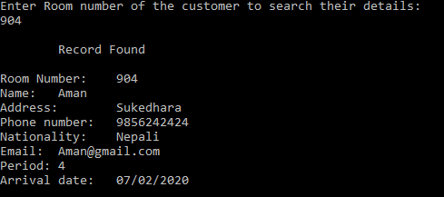

Figure 14 Search Functionality

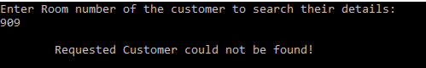

Figure 15 Search Operation for Unregistered Customer Records

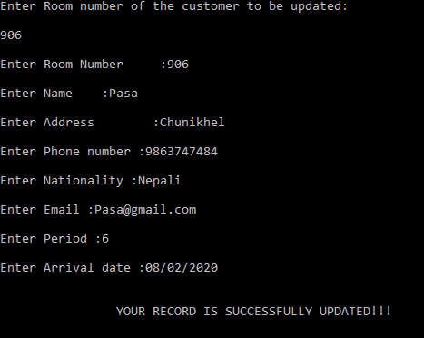

Figure 16 Edit Record

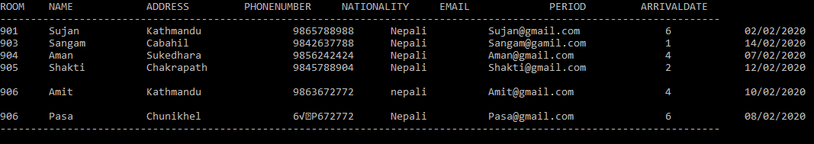

Figure 17 Customer Record after Editing

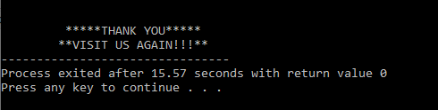

Figure 18 Exit and Thanksgiving Page

# 5.CONCLUSION

Computer has got clear advantage over the manual system. The computerized system is more reliable, efficient and fast at the end of the project. Computer does maximum work in limited time.”Hotel Management System” helps to provide maximum facilities and comfort to customers which is the main motive of any business company. It is very beneficial and positive from economic as well and service providing prospective at present time.

At the end of the program I have learned some problem solving skills by designing a Hotel Management System. I have also gained knowledge on how to build computer applications in C programming.

# REFERENCES

SCRIBD, 2010. *A Project Report on Hotel Management System*. [Online] Available at: <https://www.scribd.com/doc/26299255/A-Project-Report-on-Hotel-Management-System> [Accessed 04 February 2020].